EMERGENCY RESPONSE TEAM | Login with my username and password | The system can authenticate me and I can trust it | After successful login, the data associated to the user should be accessible
 | Monitor active incident feeds | I can provide an immediate and coordinated response | Real-time incident map/list is displayed with priority levels and GPS location
 | Coordinate rescue operations | Resources are dispatched to the emergency site efficiently | Ability to identify nearby helicopters, generate routes, and update operations status
 | Use the communication hub | I can maintain contact with ground authorities and the flight crew | Dedicated emergency chat/radio interface with timestamped logs
 | Use the communication hub | We can analyze performance and improve future safety protocols | Show list table of completed maintenance actions by date/module
 | Log out of the system | My session is secure when I'm done working | Reporting template is pre populated with incident data and exportable

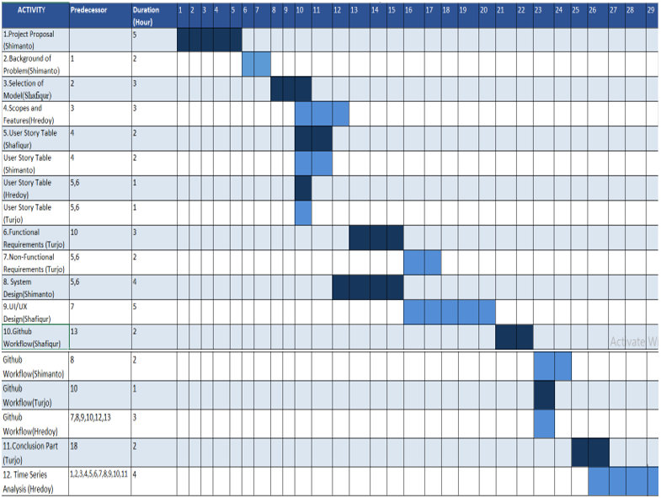

3.1 Scopes and Features
3.1.1 Users
1. Passenger
2. Pilot / Co-Pilot
3. System Admin
4. Helicopter Service Provider
5. Maintenance Engineer
6. Emergency Team
3.1.2 Scope
3.1.2.1 Authentication & User Management Features
Passengers can register an account using credentials and personal details.
- Role-based login and logout authentication for Passenger,
- Pilot/Co-Pilot, System Admin, Helicopter Service Provider, Maintenance Engineer, and Emergency Team.
- System Admin manages all user profiles, access levels, and role permissions across the system.
3.1.2.2 Passenger Booking & Travel Management Features
i. Search available helicopter flights, view real-time availability, and select specific seats.
ii. Book one-way, round-trip, and corporate rides with option to submit special travel requirements.
iii. Make secure digital payments during ride confirmation.
iv . or cancel scheduled bookings prior to departure.
v. On-demand emergency ride booking for urgent transport scenarios.
vi. Submit post-flight ratings and reviews for services received.

3.1.2.3 Flight Operations & Tracking Features
i . Real-time live helicopter flight tracking accessible by passengers, fleet providers, and emergency teams.
ii. Pilots and co-pilots access assigned flights, schedules, and log updates.
iii. Flight status updates (e.g., Scheduled, Boarding, In-Flight, Landed, Delayed) handled directly by flight crews.
iv. Automated weather alerts delivered to pilots prior to and during flight operations.

3.1.2.4 Safety, Incident & Emergency Management Features
i.Pilots complete digital pre-flight safety checklists and submit post-flight operational logs.
ii. Direct in-flight emergency reporting module for pilots.
iii. Emergency Team command hub to monitor active incidents and dispatch coordinate rescue operations.
iv. Centralized Emergency Communication Hub for cross-team coordination and post-incident reporting.

3.1.2.5 Fleet & Service Provider Operations Features
i. Service providers manage helicopter availability and fleet readiness.
ii. Assign qualified pilots and co-pilots to scheduled flight routes.
iii. Track enterprise and corporate booking requests.
iv .Monitor fuel usage, upload compliance documents, and view maintenance history logs.

3.1.2.6 Maintenance & System Engineering Features
i. Maintenance engineers view and monitor software modules and system health status.
ii. Restrict user access to faulty modules and install/upgrade system software components.
iii. Submit maintenance logs, upload technical inspection reports, and log software issue tickets.
iv. Automated alerts for urgent system issues and upcoming upgrade reminders.
3.1.2.7 System Administration & Governance Features
i. Configuration of flight routes, pricing tiers, and helipad/station locations.
ii. Live system performance monitoring and access to system activity logs/audit trails.
iii. Comprehensive customer support ticketing system to handle user disputes and inquiries.

3.1.3 Role-Specific Dashboard Scopes
- Pilot / Co-Pilot Dashboard: Access daily flight rosters, review flight schedules, complete digital pre-flight checklists, monitor weather forecasts, and log post-flight records.
- Helicopter Service Provider Dashboard: Oversee helicopter fleet status, assign flight crews, monitor fuel consumption, process B2B corporate requests, and maintain compliance records.
- Passenger Dashboard: Manage current bookings, view seat allocations, access live flight tracking, download payment receipts, and submit feedback.
- System Admin Dashboard: High-level platform analytics, route and helipad management, pricing controls, audit trail tracking, and customer ticket escalation.
- Maintenance Engineer Dashboard: Inspect software modules, review system alerts, log technical reports, update maintenance records, and deploy system upgrades.
- Emergency Team Dashboard: Real-time monitoring of active distress calls, manage emergency communication channels, deploy rescue coordination units, and document post-incident analyses.

